**Electrically Tunable Exchange Bias**

Peyton Murray1, Junwei Zhang2, Xixiang Zhang2, Kai Liu1,3*

*1Physics Department, University of California, Davis, CA 95616, USA*

*2King Abdullah University of Science & Technology, Thuwal 23955-6900, Kingdom of Saudi Arabia*

*3Physics Department, Georgetown University, Washington, DC 20057, USA*

*Corresponding author: Kai.Liu@georgetown.edu

**Abstract**

Electrically induced ionic motion offers a new way to realize voltage-controlled magnetism, opening the door to a new generation of logic, sensor, and data storage technologies. Here, we demonstrate a two-step approach towards magnetoionic control of exchange bias. First, a Gd capping layer is deposited onto thin film antiferromagnetic Ni0.5Co0.5O, initiating a solid-state redox reaction which reduces the oxide to ferromagnetic NiCo in a thin interfacial region. Upon field cooling, the hysteresis loop becomes exchange biased, demonstrating interfacial coupling between the NiCo and the remaining oxide. Second, an electric field is applied perpendicular to the interface, driving O2- ions toward the Gd layer. Subsequent magnetometry reveals an increase in the exchange bias by ~15%, while electron microscopy directly images ion-migration-induced chemical segregation and microstructural disorder. While these effects do not appear to be electrically reversible in this system, thermal cycling resets the exchange bias back to its field-cooled value. These results highlight the viability of this approach for controlling interfacial magnetic properties, and suggest new routes toward systems with improved magnetoionic performance.

Methods aiming to control magnetism using electric fields have attracted significant interest in recent years with the promise of enabling a new generation of nonvolatile, low-dissipation electronics 1–8. While prevailing semiconductor-based logic and memory technologies rely on electric currents and are therefore subject to energy losses due to joule heating, electric field-based approaches in principle have no such limitation. Recent research has shown ionic migration to be a powerful tool for modifying the magnetic properties of metallic and oxide ferromagnets. For example, several experiments have demonstrated reversible control of interfacial anisotropy in Pt/GdOx/Co trilayers1–4. In these trilayer systems, charged oxygen ions, which exist in the -2 valence state in the GdOx layer, are mobile and move under an externally applied electric field – even at room temperature. A correctly oriented electric field can therefore drive these ions towards the Co interface to initiate an oxidation reaction. The resulting changes in chemistry as well as Co-O hybridization can modify the magnetic moment1,3 or interface anisotropy2, leading to significant improvements in magneto-electric efficiency. Remarkably these effects are reported to be at least partially reversible, particularly at elevated temperatures, with reverse bias acting to reduce the Co interface back to a metallic state. As an alternative to electric-field-based approaches, we recently demonstrated control of oxygen-ion distributions using chemically-induced ionic motion triggered by a getter metal9–11; this approach involves deposition of a thin capping layer of Gd onto an oxide thin film, as discussed in Chapters 5.1 and 5.2. Due to the high oxygen affinity of Gd, a solid-state redox reaction occurs at the metal/oxide interface at room temperature, leaching oxygen from the oxide, with the amount of oxygen removed controlled by the Gd capping layer thickness9–11. In oxides with high ionic mobility, ionic migration effects can penetrate well beyond the interface, extending the utility of this approach to the quasi-bulk regime – far deeper than the effective ranges thus far demonstrated by electric-field-based techniques. This chemically-induced ionic migration mechanism has been demonstrated as an effective way to modify structure, stoichiometry, transport properties, and magnetism in a variety of functional oxides9–11.

Here, we present a new method for electrically tuning exchange bias in a thin film Ni0.5Co0.5O/Gd bilayer system. As exchange bias is central to spin-valve type devices such as magnetic tunnel junctions that enable control of magnetic configurations, magneto-ionic tuning of exchange bias may lead to substantially more energy-efficient spintronic devices than using a magnetic field. Our approach combines the extremely strong ionic migration generated by the redox-based technique with electrical biasing to allow for on-demand modification of exchange bias. Since exchange bias is extremely sensitive to changes in interfacial chemistry and morphology12–15, the effect is a delicate probe of magneto-ionic activity. In our approach, a thin metallic Gd capping layer is deposited onto antiferromagnetic (AF) Ni0.5Co0.5O (NiCoO); due to the extreme oxygen reactivity of metallic Gd, this capping layer strips oxygen away from the NiCoO, reducing the oxide near the interface to ferromagnetic (FM) NiCo alloy. Upon field cooling, the major hysteresis loop is exchange biased, demonstrating that the interfacial FM layer is magnetically coupled to pinned uncompensated moments in the remaining AF oxide. Upon application and removal of an electric field oriented perpendicular to the interface, an enhancement of the exchange bias by ~15% is observed. Electron microscopy images of the NiCoO/Gd interface show disruption to the microstructure as well as changes to the NiCo layer chemistry, both effects which can be attributed to the ionic motion. Although reverse biasing the interface has no effect on the magnetic reversal behavior thus far, further thermal cycling resets the major loop back to the field cooled state, indicating that these magneto-ionic effects may be at least partially reversible. Our results demonstrate the viability of this approach for tuning interfacial magnetism through ionic motion, and highlight a new pathway towards nonvolatile and energy efficient magnetic switching devices.

Samples used in this study were fabricated via sputter deposition and photolithography carried out in a multiple step deposition process. First, a naturally oxidized Si wafer was sputter coated with a Ta (1 nm thick) adhesion layer followed by a Pt (10 nm) layer, forming a bottom electrode. The wafer was subsequently removed from the UHV deposition chamber and patterned using standard photolithographic processing techniques, leaving a grid of 7.5 mm × 7.5 mm square regions uncovered by the resist. After returning the wafer to the UHV sputter chamber, an insulating layer of Al2O3 (170 nm) was deposited via RF sputtering from an Al2O3 target with a working gas consisting of 2% O2 / 98% Ar. Next, a layer of NiCoO (20 nm) was RF-sputtered from a stoichiometrically balanced NiCoO target in a 15% O2 / 85% Ar working gas mixture, and at 0.33 Pa working pressure. Finally, the NiCoO was capped with Gd (20 nm) followed by a layer of Pt (10 nm), with the top Pt layer acting both as a top electrode and as a barrier to protect the sample from atmospheric exposure. All deposition steps were carried out at room temperature in a UHV chamber with a base pressure in the ${10}^{-6}$ Pa range. Except for the NiCoO layer, sputtering was carried out at a working pressure of 0.67 Pa. After deposition, the sample was washed in acetone to remove the remaining photoresist, exposing the bottom electrode underneath. The final sample structure is shown in Figure 5.9.

Vibrating sample magnetometry (VSM) measurements of hysteresis loops were carried out on two identically-prepared films (samples A and B) in the as-grown state. A second measurement was made after heating the samples in an Ar environment above the NiCoO Neél temperature ()16,17 to 420 K, and then cooling to room temperature in a 10 kOe magnetic field (field cooling step). A third magnetic measurement was made after a voltage conditioning procedure, wherein a 0.5 MV/cm electric field was applied along the $+\hat{z}$-direction (Figure 5.9) for 12 hours at room temperature before being removed. After these procedures, sample A was then reverse-biased using the same voltage conditioning procedure, but with the applied electric field oriented along the $-\hat{z}$-direction; while sample B was field cooled again, by heating to 420 K and then cooling to room temperature in a 10 kOe field. Magnetic hysteresis loops were then measured on both samples a final time.

Room temperature magnetometry of the as-grown states in both samples show a nonzero ferromagnetic moment (Figure 5.10), even though none of the constituent materials exhibit ferromagnetism at this temperature (Gd K)18. Only NiCoO contains elements which are ferromagnetic in their metallic state at room temperature, indicating that a partial reduction of NiCoO has occurred (Figure 5.10). The thickness, $t$, of the magnetic layer corresponding to the observed moment can be estimated from the bulk values of the saturation magnetization of Ni ($495 emu/{cm}^{3}$) and Co ($1400 emu/{cm}^{3}$), and depends on the exact Ni:Co ratio of this layer; for these samples, $0.44 nm≲t≲1.3 nm$, with the lower and upper bounds determined assuming pure Co and pure Ni, respectively. Upon field cooling (FC), the major loop of sample A increases in coercivity $H_{c}$ from 156 Oe in the as-grown (AG) state to 192 Oe; the major loop also becomes biased, with a bias field $H_{b}=-201$ Oe (Figure 5.10a). Both of these effects are expected for an exchange biased system12–15, again suggesting the formation of a FM layer adjacent to the AF NiCoO. The emergence of a magnetic moment is also consistent with our previous study of a GdFe/NiCoO system, where an interfacial layer of NiCo was observed to form as the result of Gd-induced interfacial reduction of the oxide10. Sample B also shows similar behavior after field cooling, with $H_{c}$ increasing from 140 Oe to 221 Oe, and an exchange bias field of $H_{b}=-283$ Oe.

Sample A shows a shift in the major loop after applying an electric field along the $+\hat{z}$-direction for 12 hours at room temperature. Magnetometry of the resulting voltage-conditioned (FC+VC) state shows an increase in the coercivity from $H_{c}=192$ Oe after field cooling to $H_{c}=214$ Oe (Figure 5.10a). In this orientation of the electric field, O2- ions in the NiCoO layer are expected to drift towards Gd. Subsequent reverse-bias voltage conditioning was carried out at room temperature using the same 0.5 MV/cm electric field applied for 12 hours in the $-\hat{z}$-direction. This reverse-bias voltage conditioned (FC+VC-VC) state showed no observable change in hysteretic behavior. Although reverse biasing had no effect at room temperature, ionic diffusion is known to be enhanced at elevated temperatures19. To examine the thermal stability of the voltage-conditioned (FC+VC) state, sample B was prepared similarly to sample A: following the same field cooling procedure as for sample A, the major loop increased in coercivity from $H_{c}=140$ Oe (AG state) to $H_{c}=221$ Oe (FC state), and the loop showed exchange bias, with $H_{b}=-283$ Oe (Figure 5.10b). The same voltage conditioning procedure, with the electric field oriented along $+\hat{z}$, again caused an enhancement in the coercivity to $H_{c}=230$ Oe and an increase in the exchange bias to $H_{b}=-308$ Oe in the field-cooled voltage conditioned (FC+VC) state. Finally, in a second field cooling procedure, the sample was again heated to 420 K and then cooled to room temperature in a 10 kOe field. A subsequent magnetometry measurement (FC+VC+FC) shows the major loop returning from the voltage-conditioned state back to the original field cooled state (Figure 5.10b).

To further understand the evolution of the interfacial FM layer after field cooling and voltage conditioning, scanning transmission electron microscopy (STEM) was carried out on three additional samples prepared in AG, FC, and FC+VC states, in collaboration with Junwei Zhang and Xixiang Zhang of King Abdullah University of Science & Technology (KAUST). Representative images of the NiCoO/Gd interface show small, randomly oriented crystallites identifiable as regions of uniform and parallel lattice fringes, indicating that both materials form polycrystalline grains during growth (Figure 5.11a). After field cooling, only a few crystal planes are visible; as thermal treatment often improves crystallinity20, this disorder is may be due to dislocations induced by ionic migration, which is enhanced by the elevated temperatures reached during field cooling (Figure 5.11b). After voltage conditioning (Figure 5.11c) the imaged region remains largely disordered, and the interface becomes even less abrupt. While NiCoO grains are visible in the AG and FC samples, none are visible in the FC+VC sample. Since ionic diffusion is expected to be enhanced at grain boundaries19,21, the disruption of the NiCoO grains is likely responsible for the irreversibility of the voltage-conditioning effects under reverse bias. Also present is a dark layer running parallel to the interface of the FC and FC+VC samples; the origin of this dark layer is not yet understood.

In addition to microscopy, elemental distributions were mapped across the NiCoO/Gd interfaces via electron energy loss spectroscopy (EELS). The cross-sectional distributions of Co (blue curve), Ni (green curve), Gd (yellow curve), and O (brown curve) for the AG state are shown as a function of depth through the sample in Figure 5.12a, with the Gd layer shown at left, and NiCoO shown at right. The Gd distribution drops to zero in the same region where the Ni and Co signals increase from zero to a finite value, signaling the NiCoO/Gd interface. Far away from the Gd interface, the Ni and Co distributions saturate deep within the NiCoO layer. The O distribution is nonzero inside the Gd layer, indicating at least partial oxidation of Gd has occurred, and increases correspondingly with the presence of Ni and Co, as expected for NiCoO. In the FC state, the oxygen concentration remains low until deep within the NiCoO layer, well after the Ni and Co distributions begin to rise, meaning that the interface is largely metallic (Figure 5.12b). This observation therefore constitutes the first direct confirmation of the presence of the NiCo metallic layer proposed previously10, which is expected to form as a result of Gd-induced oxygen leaching. Interestingly, the Ni distribution (green curve) rises significantly sooner than the Co distribution (blue curve), indicating that the Ni is nearer to the Gd layer than the Co. This segregation of the Ni and Co atoms occurs only near the Gd interface, despite equal fractions of both atomic species being present in the as-grown NiCoO; deeper within the NiCoO layer and far from the interface, these distributions saturate, indicating that the Ni:Co ratio is only altered near the Gd interface. This chemical segregation arises as a result of the lower alloying enthalpy of formation of Gd-Ni alloys as compared to Gd-Co alloys22,23. During the initial field cooling, oxygen migration from the NiCoO to the Gd layer leaves behind metallic NiCo; as a result of Gd-Ni alloys being energetically favored over Gd-Co, the Ni atoms are drawn deeper into the Gd layer away from the remaining NiCoO, accounting for the Ni enrichment near the interface. EELS analysis shows significant overlap of the Gd and Ni distributions, in agreement with this model (Figure 5.12b). Upon voltage conditioning, further segregation between the Ni and Co elemental distributions is observed, beyond that observed after field cooling (Figure 5.12c). Once again, the oxygen distribution only increases to its saturation value well after the point at which the Gd distribution goes to zero, again confirming the presence of an interfacial metallic layer. In this case, however, the interfacial layer is almost entirely composed of Ni, again pointing to the formation of a Gd-Ni alloy, and suggesting that voltage conditioning acts to further increase the size of the chemical segregation effect.

The magnetic behavior of the NiCoO/Gd system is the result of two separate ion migration mechanisms. The first occurs during deposition of the Gd layer, which results in a chemically-induced redox reaction which strips oxygen from the adjacent NiCoO, leaving behind the ferromagnetic NiCo observed in magnetometry of the as-grown sample. This gadolinium oxidation process is exothermic, with a change in enthalpy $ΔH$ of –11.4 eV per molecule of Gd2O3 formed (3(Ni, Co)O + 2Gd 3(Ni, Co) + Gd2O3) 24. Thus, local heating may help to increase ionic mobility in the surrounding region, although the degree to which this feedback effect enhances the redox reaction is difficult to quantify due to the inhomogeneity of the interface. While the magnetic moment observed in magnetometry corresponds to a layer thickness of only ~6.5 Å assuming equal Ni and Co concentration, the disordered region formed near the NiCoO/Gd interface is actually much wider, likely due to disrupting effects of ionic migration. The magnetization of this structurally disordered region is likely to be lower than expected for a binary alloy, owing to residual oxygen content and different atomic coordination as compared to the crystalline phase. As this system is field cooled, the enhanced ionic mobility combined with the chemical potential gradient provided by the Gd layer induces additional oxygen migration beyond that of the as-grown state, further disrupting the interfacial region. The resulting disorder is observed in the STEM image of the FC sample. After field cooling, the hysteresis loop is exchange biased by the coupling between the FM NiCo and the remaining AF NiCoO.

The second ion migration mechanism is electric field induced motion. During voltage conditioning, oxygen ions migrate toward the Gd layer, acting to mix and further disorder the interface beyond that observed in the FC sample. As the interfacial FM layer is mixed, the NiCo alloy becomes increasingly Ni-enriched via the alloying-enthalpy mechanism discussed previously. As the ratio of Ni () to Co () 18 increases, the magnetization of the interfacial layer decreases below that of the FC state. Additionally, the thickness of this layer may also change as a result of the introduction of structural disorder; according to Malozemoff’s random field model25, the observed exchange bias is inversely proportional to both the saturation magnetization and the thickness of the ferromagnetic layer:

$$\begin{aligned}H_{b}=\frac{2z\sqrt{AK}}{π^{2}M_{s}t}\end{aligned}$$

where $A$ and $K$ are the AF layer exchange stiffness and anisotropy, $M_{s}$ and $t$ are the ferromagnetic layer saturation magnetization and thickness, and $z$ is a number of order unity which depends on the shape of the antiferromagnetic domains. The increase in the bias observed in the hysteresis loops of the FC and FC+VC states suggest that the quantity $M_{s}t$, which corresponds to the magnetic moment of the ferromagnetic NiCo at the interface, decreases as a result of voltage conditioning; this may be due to a decrease in thickness, as oxygen migration through the interfacial magnetic layer alters the structure – or due to a decrease in the magnetization of the interfacial layer resulting from Ni enrichment. Both effects act to increase the exchange bias field, in agreement with the measured hysteresis loops of the FC and FC+VC states.

One possible explanation for the irreversibility of the magneto-ionic effects observed in this system relates to the relative ionic diffusivities along grain boundaries and through the bulk. At room temperature, diffusion along grain boundaries is typically energetically favorable19; at elevated temperatures, bulk diffusion becomes important, and both the bulk and grain boundary diffusivities converge. Upon field cooling of a pristine sample, the elevated temperatures reached during the thermal cycling process is therefore expected to enhance both diffusivities, allowing oxygen migration from the NiCoO toward the Gd both from the bulk and along grain boundaries. This ionic migration acts to disorder the NiCoO near the Gd interface, as can be seen in Figure 5.11b, but does not fully disrupt the NiCoO grain boundaries, which are still visible in the image. Subsequent room temperature voltage conditioning, however, is expected to cause ionic migration primarily along grain boundaries, where the diffusion constant is lowest; thus, the most disruption and disordering due to ionic migration is expected at the grain boundaries. Indeed, in the FC+VC STEM image (Figure 5.11c), only certain crystalline planes are observed over nanometer scale regions whose boundaries are highly disordered, in agreement with this explanation. Since ion mobility is expected to be highest along these grain boundary pathways, disruption to these pathways renders the ionic distributions immobile under reverse bias, meaning that voltage-biasing in this material may be expected to only cause significant ionic migration once. Importantly, the magnetometry of the FC+VC+FC state shows that a second field cooling procedure can reset the exchange bias back to its original value. Since bulk ionic diffusivity is enhanced at elevated temperature, grain boundaries are not as important for ionic migration during field cooling, allowing the interface to recover to the pre-voltage-conditioned state.

In summary, the magneto-ionic control and electric field manipulation of exchange bias in NiCoO/Gd have been investigated. The formation of a ferromagnetic NiCo layer near the interface was established; this interfacial layer forms as a result of oxygen ion migration induced by a solid state Gd-oxidation reaction, and is observed via magnetometry and EELS. Field cooling behavior typical of exchange biased FM/AF system was observed, with the interfacial NiCo coupling to the remaining antiferromagnetic NiCoO. Importantly, the exchange bias in this system is enhanced by up to 15% by applying an electric field perpendicular to the interface. Electron energy loss spectra show that upon field cooling, the interfacial region become Ni-rich; this chemical segregation becomes more dramatic after voltage biasing. Malozemoff’s random field model suggests that the reduction of the ferromagnetic NiCo moment observed at the interface is responsible for the enhancement of the exchange bias in the voltage biased state. Finally, this effect was found to be reversible under thermal cycling but not under reverse biasing, due to ionic-migration-induced disruption of grain boundaries near the interface, which comprise the most effective ionic migration pathways. These results demonstrate a new magneto-ionic approach for controlling exchange bias, with greater switching speed and larger changes to the bias likely possible with further material optimization and improved fabrication processes.

**References**

1. Gilbert, D. A. *et al.* Structural and magnetic depth profiles of magneto-ionic heterostructures beyond the interface limit. *Nat. Commun.* **7,** 12264 (2016).

2. Bauer, U. *et al.* Magneto-ionic control of interfacial magnetism. *Nat. Mater.* **14,** 174–181 (2015).

3. Bi, C. *et al.* Reversible control of Co magnetism by voltage-induced oxidation. *Phys. Rev. Lett.* **113,** 267202 (2014).

4. Bauer, U., Emori, S. & Beach, G. S. D. Voltage-controlled domain wall traps in ferromagnetic nanowires. *Nat. Nanotechnol.* **8,** 411–416 (2013).

5. Chu, Y.-H. *et al.* Electric-field control of local ferromagnetism using a magnetoelectric multiferroic. *Nat. Mater.* **7,** 478–482 (2008).

6. Weisheit, M. *et al.* Electric Field-Induced Modification of Magnetism in Thin-Film Ferromagnets. *Science* **315,** 349–351 (2007).

7. Ohno, H. *et al.* Electric-field control of ferromagnetism. *Nature* **408,** 944–946 (2000).

8. Wolf, S. A. Spintronics: A Spin-Based Electronics Vision for the Future. *Science* **294,** 1488–1495 (2001).

9. Grutter, A. J. *et al.* Reversible control of magnetism in La0.67Sr0.33MnO3 through chemically-induced oxygen migration. *Appl. Phys. Lett.* **108,** 082405 (2016).

10. Gilbert, D. A. *et al.* Controllable positive exchange bias via redox-driven oxygen migration. *Nat. Commun.* **7,** 11050 (2016).

11. Gilbert, D. A. *et al.* Ionic tuning of cobaltites at the nanoscale. *Phys. Rev. Mater.* **2,** 104402 (2018).

12. Nogués, J. & Schuller, I. K. Exchange bias. *J. Magn. Magn. Mater.* **192,** 203–232 (1999).

13. Kiwi, M. Exchange bias theory. *J. Magn. Magn. Mater.* **234,** 584–595 (2001).

14. Ohldag, H. *et al.* Correlation between Exchange Bias and Pinned Interfacial Spins. *Phys. Rev. Lett.* **91,** 2–5 (2003).

15. Berkowitz, A. E. & Takano, K. Exchange anisotropy — a review. *J. Magn. Magn. Mater.* **200,** 552–570 (1999).

16. Ambrose, T., Liu, K. & Chien, C. L. Doubly exchange-biased NiCoO/NiFe/Cu/NiFe/NiCoO spin valves. *J. Appl. Phys.* **85,** 6124–6126 (1999).

17. Yang, D. Z. *et al.* Positive exchange biasing in GdFe/NiCoO bilayers with antiferromagnetic coupling. *Phys. Rev. B* **71,** 144417 (2005).

18. Kittel, C. *Introduction to Solid State Physics*. (John Wiley & Sons, Inc, 2005).

19. Balluffi, R. W., Allen, S. M. & Carter, W. C. *Kinetics of Materials*. (A. John Wiley & Sons, 2005).

20. Hotovy, I., Liday, J., Spiess, L., Sitter, H. & Vogrincic, P. Study of Annealed NiO Thin Films Sputtered on Unheated Substrate. *Japanese J. Appl. Physics, Part 2 Lett.* **42,** (2003).

21. Kim, Y. M. *et al.* Probing oxygen vacancy concentration and homogeneity in solid-oxide fuel-cell cathode materials on the subunit-cell level. *Nat. Mater.* **11,** 888–894 (2012).

22. Colinet, C., Pasturel, A. & Buschow, K. H. J. Study of the Enthalpies of Formation in the Gd-Ni System. *Metall. Trans. A* **17A,** (1986).

23. Colinet, C., Pasturel, A. & Buschow, K. H. J. Study of the enthalpies of formation in the Gd-(Fe, Co, Pd, Pt) systems. *Metall. Trans. A* **18,** 903–907 (1987).

24. Dean, J. A. *Lange’s Handbook of Chemistry*. (McGraw-Hill, 1999).

25. Malozemoff, A. P. Random-field model of exchange anisotropy at rough ferromagnetic- antiferromagnetic interfaces. *Phys. Rev. B* **35,** 3679–3682 (1987).

**Acknowledgements:** We thank Professor Yayoi Takamura from UC Davis for helpful discussions.

**Author contributions:** P.D.M and K.L coordinated the project.P.D.M. synthesized the samples, carried out magnetic measurements, and wrote a first draft of the manuscript. J.Z. and X.Z carried out microscopy studies. All authors contributed to data analysis and manuscript revision. **Competing interests:** The authors declare no competing interests. **Data and materials availability:** Experimental data is available upon request.

**Figures**

**Figure 1.** Layer structure of the samples, with the height of the patterned Al2O3/NiCoO/Gd/Pt structures greatly exaggerated. Inset shows a magnified view of the NiCoO/Gd interface, with the emergent metallic NiCo layer explicitly shown. The arrow denotes the $+\hat{z}$ direction.

**Figure 2.** (a) Sequential hysteresis loops of sample A in the as-grown (AG) state, after field cooling (FC), after voltage conditioning (FC+VC), and after reverse biasing (FC+VC-VC). (b) Sequential hysteresis loops of sample B in the as-grown (AG) state, after field cooling (FC), after voltage conditioning (FC+VC), and after a second field cooling procedure (FC+VC+FC).

**Figure 3.** STEM images of the Gd/NiCoO interface in the (a) as-grown (AG) state, (b) after field cooling (FC), and (c) after field cooling+voltage conditioning (FC+VC). (Images taken by Junwei Zhang and Xixiang Zhang at KAUST).

**Figure 4.** Normalized elemental distributions of Gd, Ni, Co, and O for the (a) as grown state, (b) after field cooling, and (c) after field cooling+voltage conditioning, as measured by EELS. The zero of the z-coordinate is arbitrarily set such that the interface is in the center of the plot.

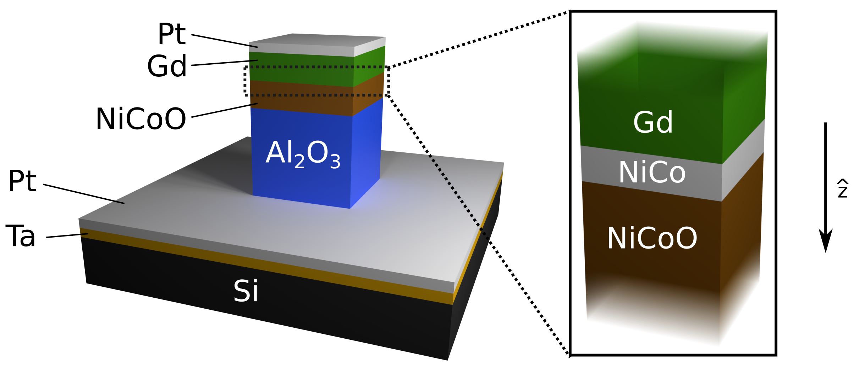

**Fig. 1**

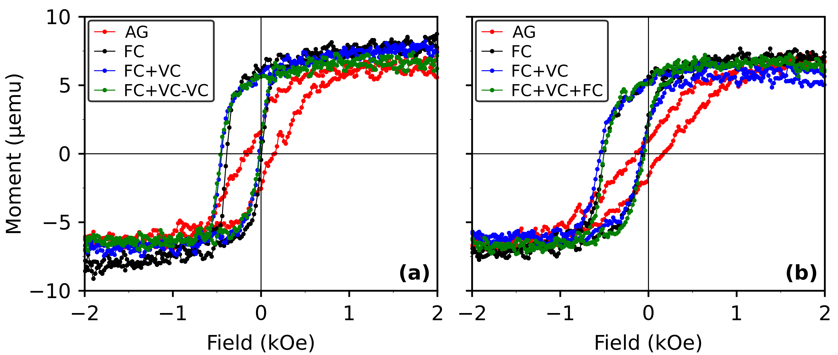

**Fig. 2**

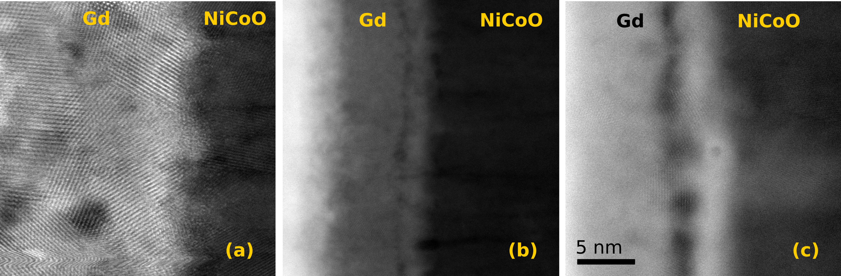

**Fig. 3**

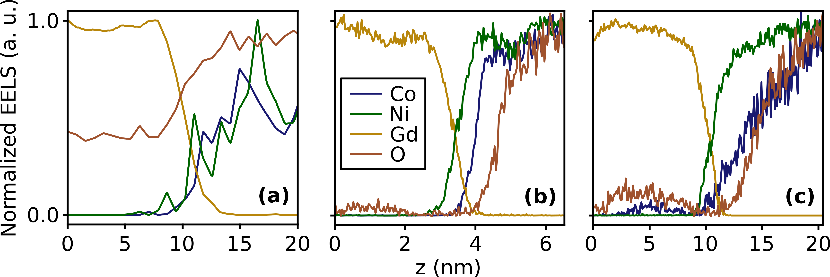

**Fig. 4**

**References**

1. Gilbert, D. A. *et al.* Structural and magnetic depth profiles of magneto-ionic heterostructures beyond the interface limit. *Nat. Commun.* **7,** 12264 (2016).

2. Bauer, U. *et al.* Magneto-ionic control of interfacial magnetism. *Nat. Mater.* **14,** 174–181 (2015).

3. Bi, C. *et al.* Reversible control of Co magnetism by voltage-induced oxidation. *Phys. Rev. Lett.* **113,** 267202 (2014).

4. Bauer, U., Emori, S. & Beach, G. S. D. Voltage-controlled domain wall traps in ferromagnetic nanowires. *Nat. Nanotechnol.* **8,** 411–416 (2013).

5. Chu, Y.-H. *et al.* Electric-field control of local ferromagnetism using a magnetoelectric multiferroic. *Nat. Mater.* **7,** 478–482 (2008).

6. Weisheit, M. *et al.* Electric Field-Induced Modification of Magnetism in Thin-Film Ferromagnets. *Science* **315,** 349–351 (2007).

7. Ohno, H. *et al.* Electric-field control of ferromagnetism. *Nature* **408,** 944–946 (2000).

8. Wolf, S. A. Spintronics: A Spin-Based Electronics Vision for the Future. *Science* **294,** 1488–1495 (2001).

9. Grutter, A. J. *et al.* Reversible control of magnetism in La0.67Sr0.33MnO3 through chemically-induced oxygen migration. *Appl. Phys. Lett.* **108,** 082405 (2016).

10. Gilbert, D. A. *et al.* Controllable positive exchange bias via redox-driven oxygen migration. *Nat. Commun.* **7,** 11050 (2016).

11. Gilbert, D. A. *et al.* Ionic tuning of cobaltites at the nanoscale. *Phys. Rev. Mater.* **2,** 104402 (2018).

12. Nogués, J. & Schuller, I. K. Exchange bias. *J. Magn. Magn. Mater.* **192,** 203–232 (1999).

13. Kiwi, M. Exchange bias theory. *J. Magn. Magn. Mater.* **234,** 584–595 (2001).

14. Ohldag, H. *et al.* Correlation between Exchange Bias and Pinned Interfacial Spins. *Phys. Rev. Lett.* **91,** 2–5 (2003).

15. Berkowitz, A. E. & Takano, K. Exchange anisotropy — a review. *J. Magn. Magn. Mater.* **200,** 552–570 (1999).

16. Ambrose, T., Liu, K. & Chien, C. L. Doubly exchange-biased NiCoO/NiFe/Cu/NiFe/NiCoO spin valves. *J. Appl. Phys.* **85,** 6124–6126 (1999).

17. Yang, D. Z. *et al.* Positive exchange biasing in GdFe/NiCoO bilayers with antiferromagnetic coupling. *Phys. Rev. B* **71,** 144417 (2005).

18. Kittel, C. *Introduction to Solid State Physics*. (John Wiley & Sons, Inc, 2005).

19. Balluffi, R. W., Allen, S. M. & Carter, W. C. *Kinetics of Materials*. (A. John Wiley & Sons, 2005).

20. Hotovy, I., Liday, J., Spiess, L., Sitter, H. & Vogrincic, P. Study of Annealed NiO Thin Films Sputtered on Unheated Substrate. *Japanese J. Appl. Physics, Part 2 Lett.* **42,** (2003).

21. Kim, Y. M. *et al.* Probing oxygen vacancy concentration and homogeneity in solid-oxide fuel-cell cathode materials on the subunit-cell level. *Nat. Mater.* **11,** 888–894 (2012).

22. Colinet, C., Pasturel, A. & Buschow, K. H. J. Study of the Enthalpies of Formation in the Gd-Ni System. *Metall. Trans. A* **17A,** (1986).

23. Colinet, C., Pasturel, A. & Buschow, K. H. J. Study of the enthalpies of formation in the Gd-(Fe, Co, Pd, Pt) systems. *Metall. Trans. A* **18,** 903–907 (1987).

24. Dean, J. A. *Lange’s Handbook of Chemistry*. (McGraw-Hill, 1999).

25. Malozemoff, A. P. Random-field model of exchange anisotropy at rough ferromagnetic- antiferromagnetic interfaces. *Phys. Rev. B* **35,** 3679–3682 (1987).